Week 2 lab submission for Cloud Computing Architechture

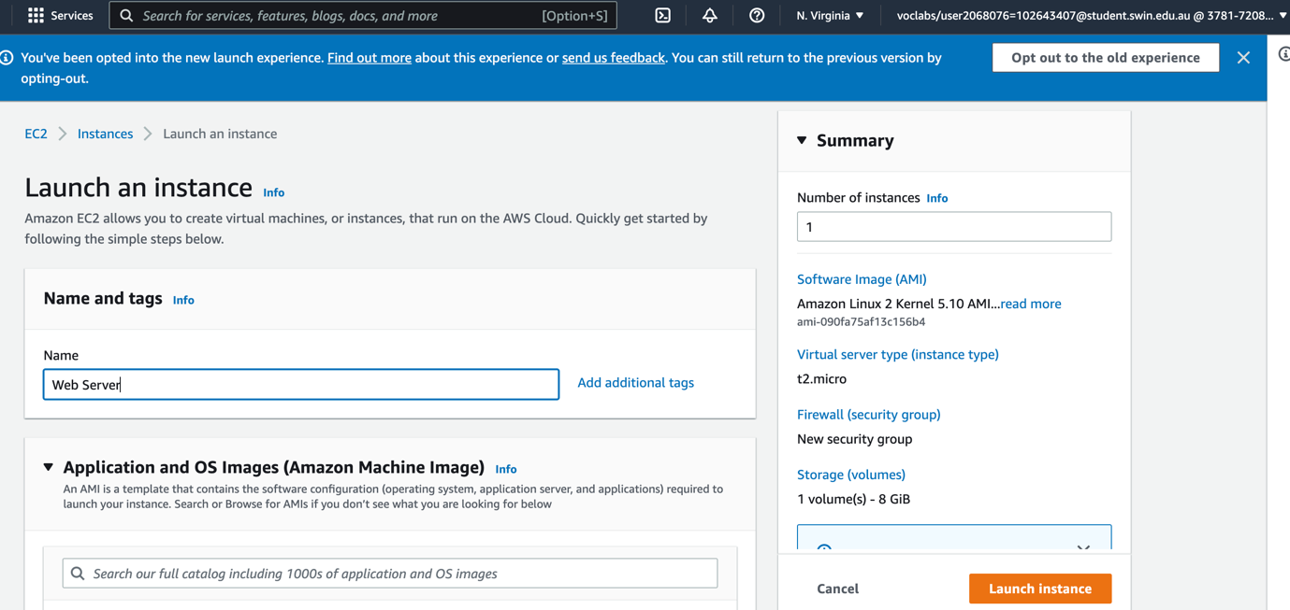

Setup and launch an instance

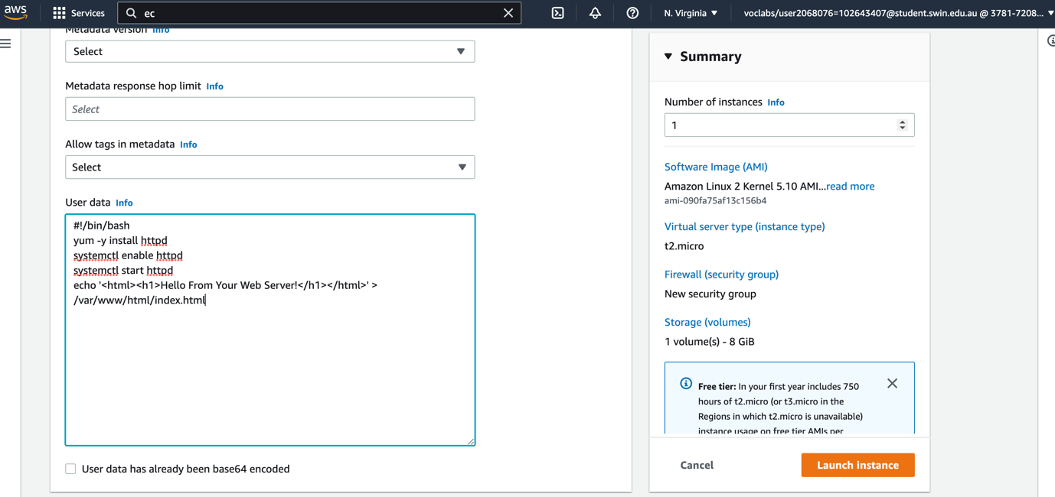

Last setup step before launching instance

Successfully launching an instance

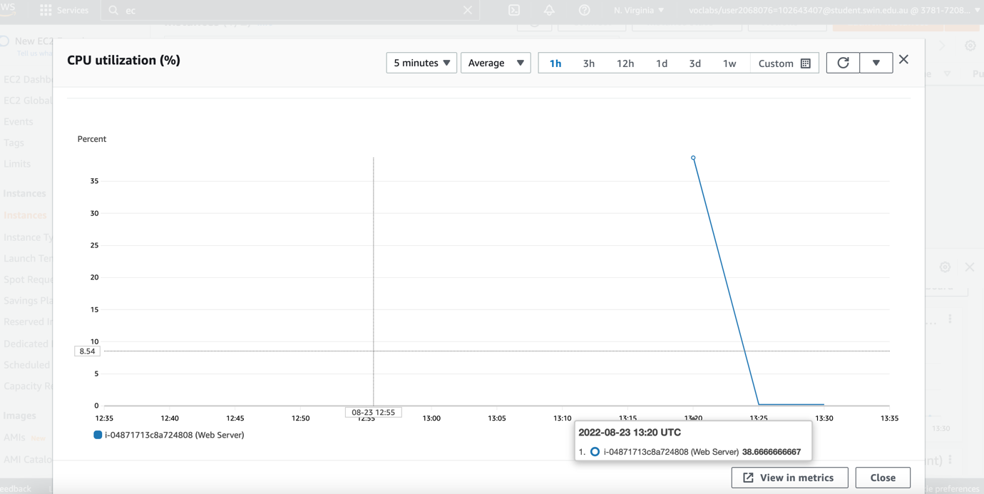

Enlarge a graph in monitoring tab

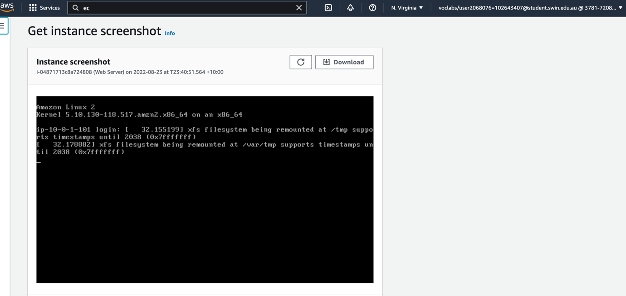

Screenshot of E2C instance console

Successfully modify security group

Stop an instance state to resize instance

Change instance type

Increase the size of the disk

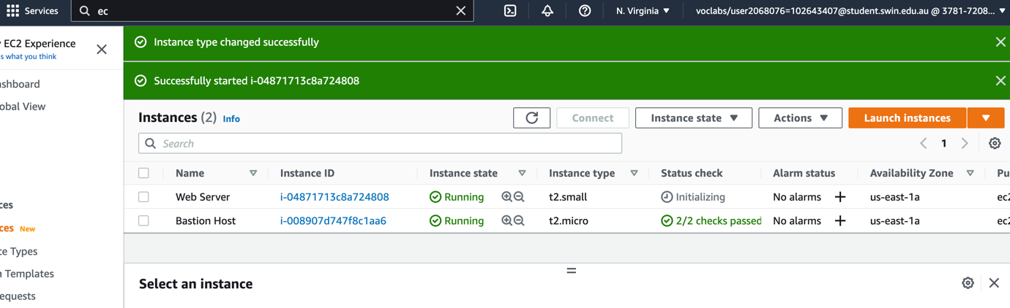

Run the instance again

Explore limit

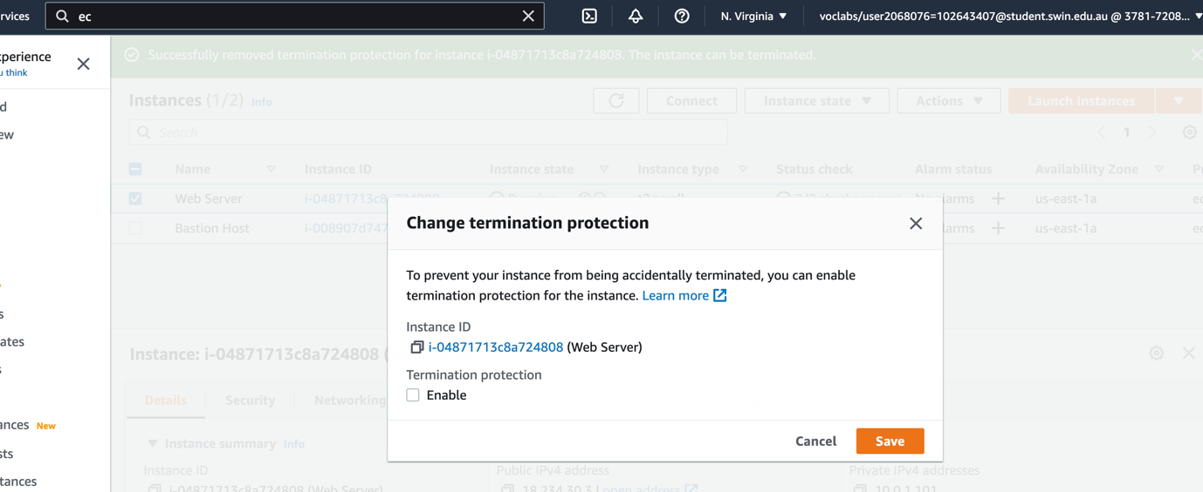

Change termination protection status

Successfully terminate an instance

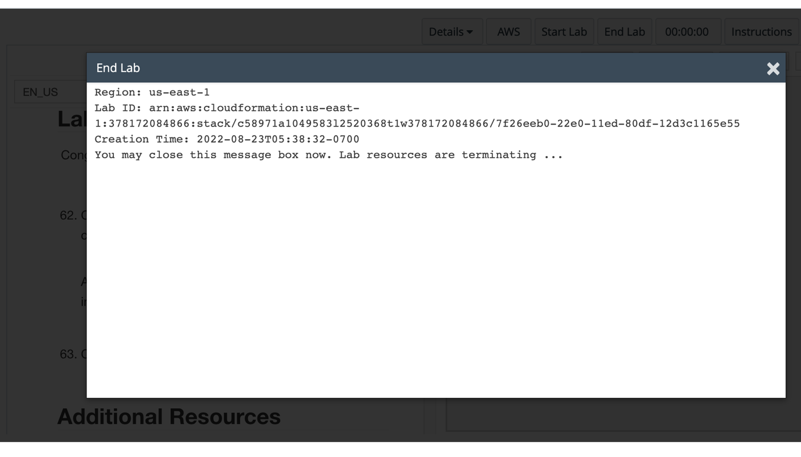

End lab